39. HR Officers record staff salaries
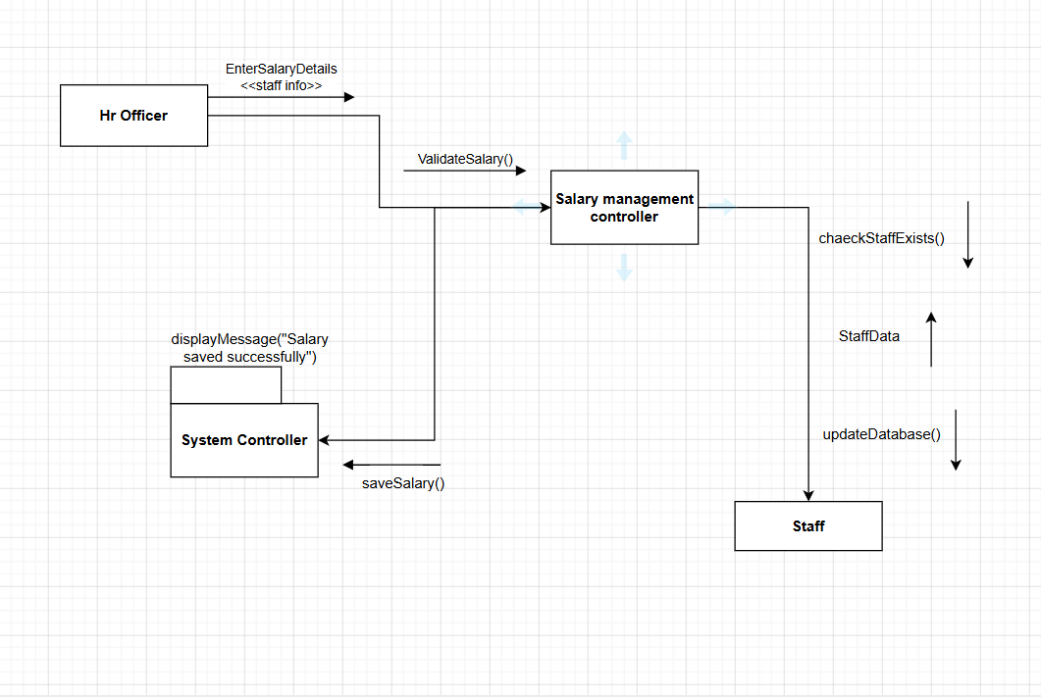

40. HR Officers process staff payroll payments
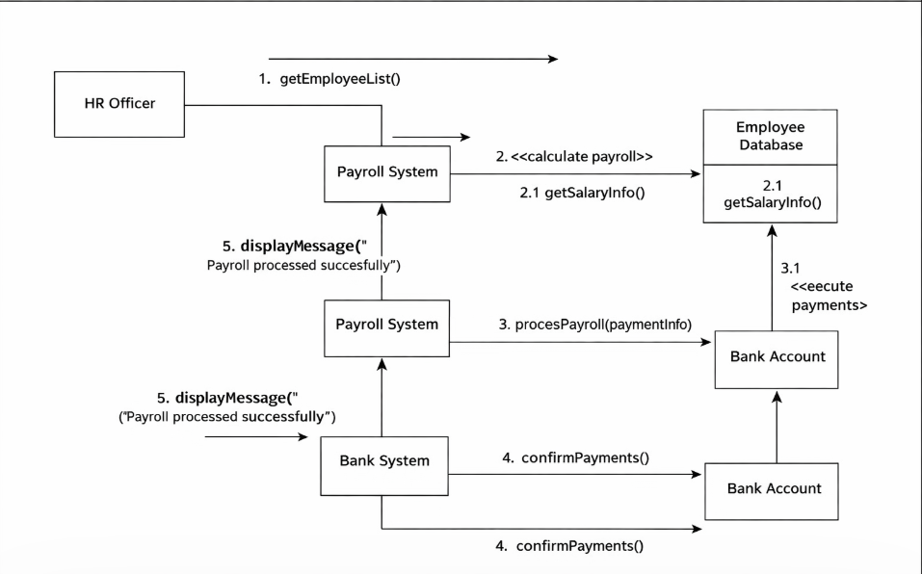

41. HR Officers and Administrators generate payroll reports
